AS you see the dark beautiful space.
As you see lots of stars you see.
Lots of colours to see so take pictures and go back to earth. 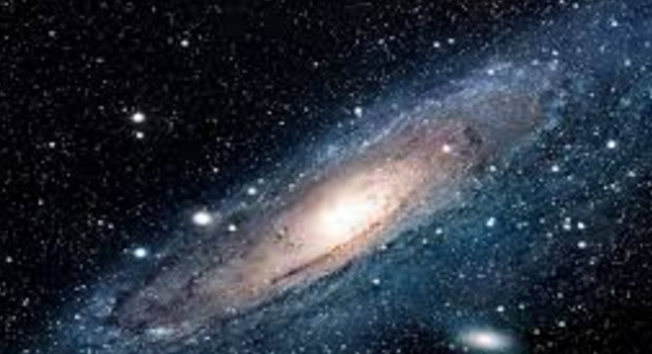 by Dionne.

