Character Description:
Write a story starter character description for the character you created last week.

Here’s mine as an example:
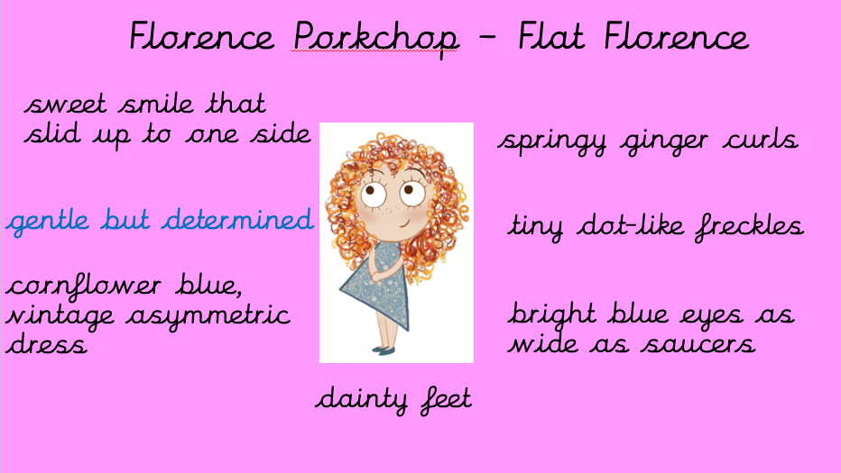

You could never call Florence a big child, but she certainly wasn’t skinny either. And what made her look even bigger than she really was, were the mass of thick, springy, ginger curls that fell in tangle from her head, and framed her pale beautiful face. Dotted with tiny brown freckles, Florence’s left cheek gave way to a sweet smile. Her eyes were bright blue and as wide as saucers. Florence often wore her favourite, cornflower blue asymmetric dress and matching ballerina pumps adorned her dainty feet. Florence looked altogether sweet and gently, which she was, but she could also be incredibly determined whenever she set her mind to it.

