How to access Emerald Class files on Teams
Open your web browser (Internet Explorer / Safari / Chrome etc.)
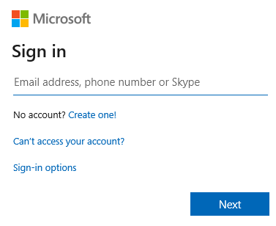
Go to: https://teams.microsoft.com/
Enter the user name followed by @townley.cambs.sch.uk

Click Next
Enter the password

Choose whether to stay signed in or not and progress to the next screen.
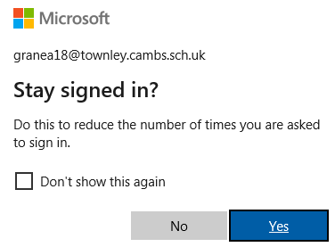
At the next screen, select “Use the Web App instead” and you will be taken to the Townley Teams pages.
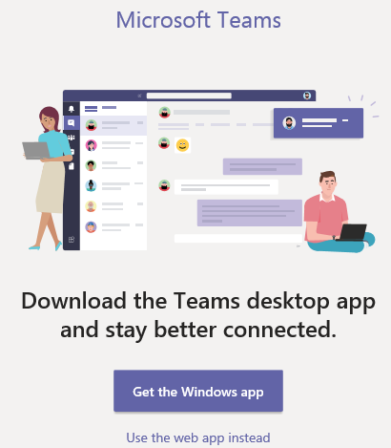
Our class page will look like this:
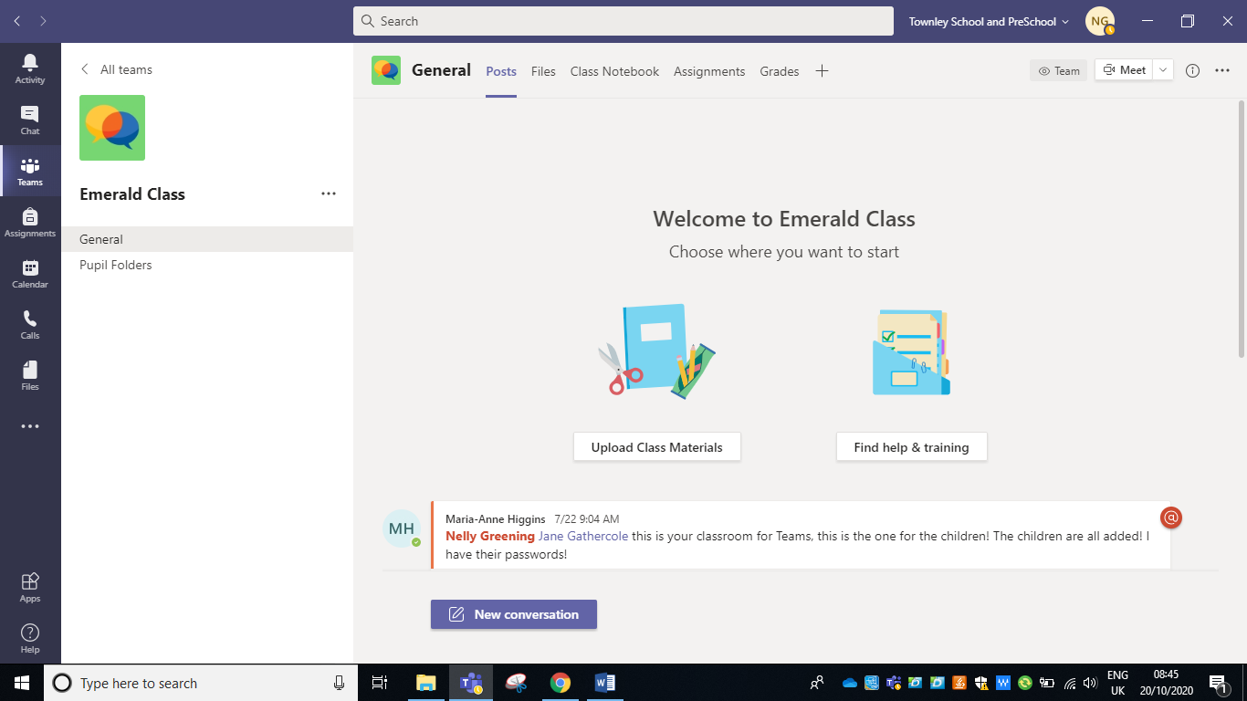
Click on Emerald Class and then go to the Files tab at the top of the page.

