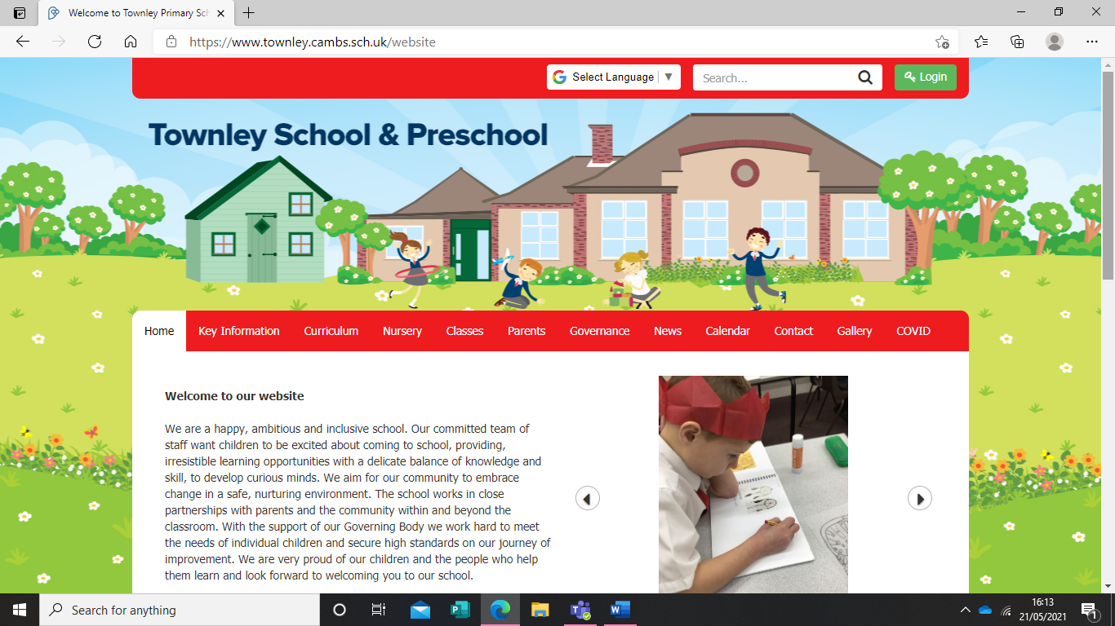
Log into our website (I’m sure you all have it saved as a favourite )

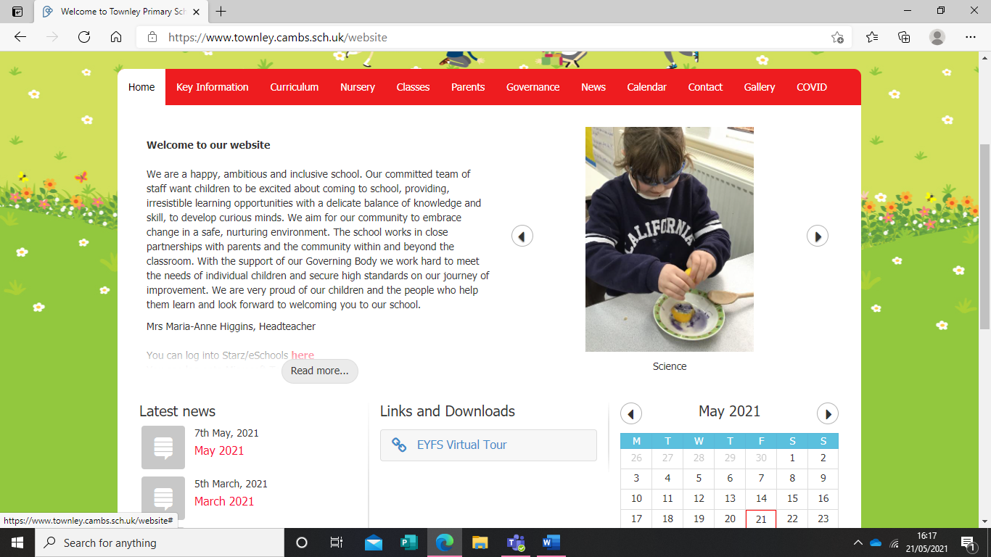

Scroll down and click on “read more”
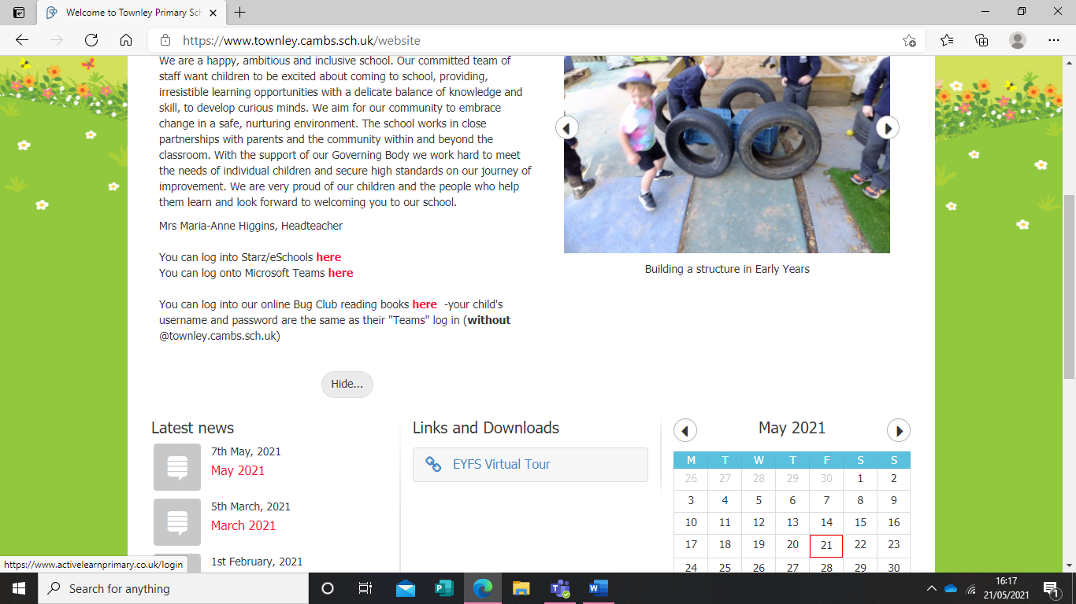
Click on the red “here”

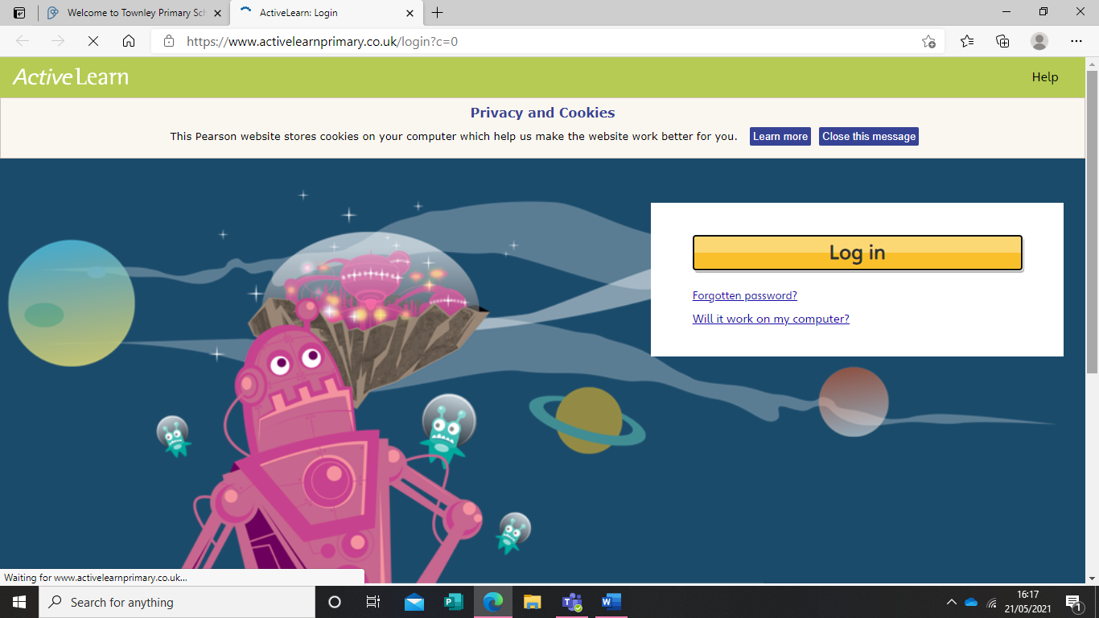
This is the screen you should see. Accept all cookies and click “Log in”
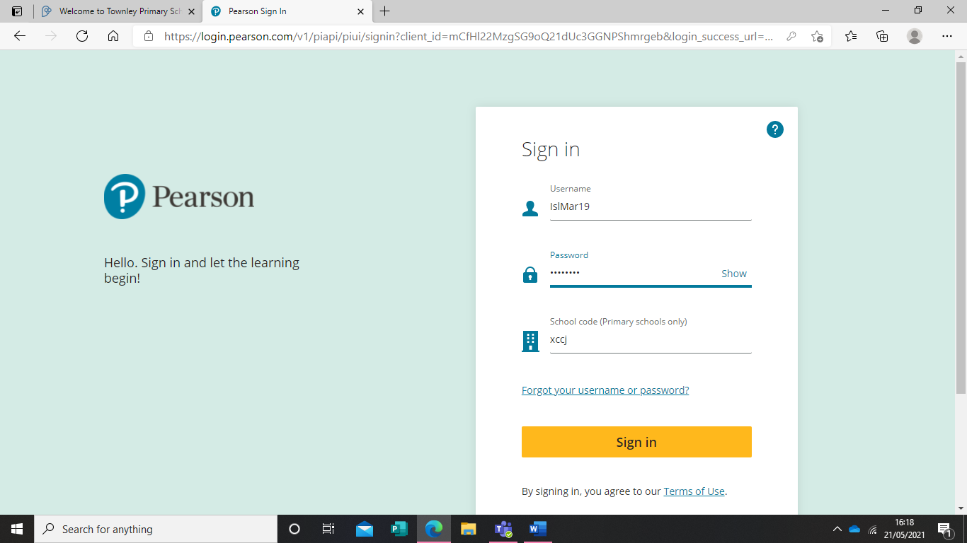
Enter username and password supplied in this format, with the school code xccj, click sign in.

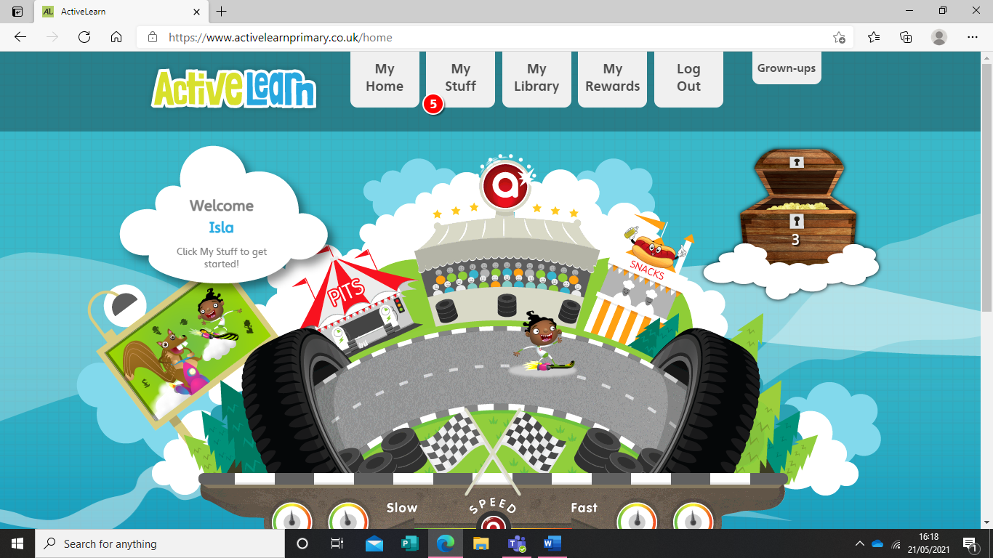
And you are in! Your child will have used Bug Club in school and should be able to navigate the website from here. Please let us know if you have any issues.

