Year A 2021 – 2022 curriculum content on a page
Autumn 2021 | Spring 2022 | Summer 2022
CUSP Reading  - All Aboard the Empire Windrush.  - The Island.  - Intro to Dickens - Oliver Twist | - Pig Heart Boy.  - How to Live Forever.  - Rooftoppers.  - The Listeners – Walter de la Mare. | - Skellig.  - A Carol From Flanders – Frederick Niven.  - Dare to be You.  - Shakespeare’s Sonnets: – Sonnet 27.
CUSP Writing  Introduce = green (Block A)  Revisit = orange (Block B)  - Autobiography – builds on CUSP famous naturalists.  - First person stories with a moral.  - Poems that create images and explore vocabulary (War poetry) – Remembrance.  - Discursive writing and speeches – builds on CUSP Study of Europe.  - Explanatory text – builds on CUSP phenomena of light.  - Shakespeare (Sonnets). | - Explanatory texts – builds on CUSP Circulatory system.  - Autobiography – builds on CUSP sporting heroes.  - Extended third person narrative (adventure stories) – builds on CUSP Disaster stories.  - Newspaper report – builds on CUSP natural disasters / Bletchley Park Computing.  - First person stories with a moral. | - Extended third person narrative (adventure stories).  - Newspaper report – builds on CUSP conflict and peace.  - Poems that create images and explore vocabulary – builds on CUSP conflict and peace.  - Discursive writing and speeches.  - Shakespeare (Sonnets).
Maths  Place Value, Four operations, Fractions (touch on Decimals and Percentages) | Geometry - properties of shapes (1)  Geometry - position and direction  Decimals and Percentages (recap fractions)  Practice tests  Algebra  Measure  Statistics | Ratio and proportion  SATs prep
CUSP Art and Design  - Drawing  - Painting and collage | - Printmaking and textiles  - 3D | - NEW module  - School study or revisit previous module and sophisticate / elaborate
Computing (Kapow)  - Online safety  - Bletchley Park 1 | - Bletchley Park 2  - Intro to Python | - Big data 1 or 2  - Skills showcase
Design and Technology (Kapow)  - Structures - playground  - Mechanical – Automata toys | - Food technology – Come dine with me  - Textiles - waistcoats | - Food technology – eating seasonally  - Electrical – steady hand game
CUSP Geography  - Comparison study – UK, Europe and North or South America | - Physical processes: Earthquakes, mountains and volcanoes | - Settlements  - NEW Maps and orienteering
CUSP History  - Windrush generation | - Beyond 1066  - 5 significant monarchs  or…  - The Battle of Britain (NEW) | - NEW – Local History Study
Music  - The inter-related dimensions of music: Tempo, Dynamics, Duration, Structure, Pitch, Timbre, Texture  - Lyrics | Music  - Instrumental Composition  - Analysis of songs | Music  - Recording/Critical listening  - Film Music
MfL  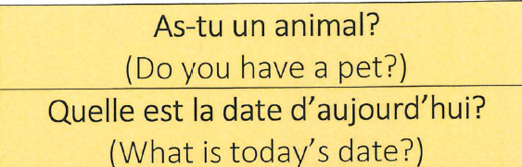 | MfL  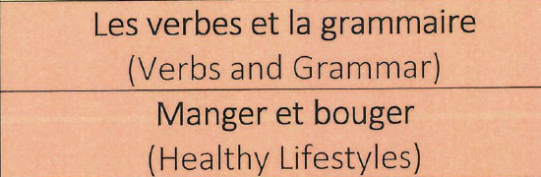 | MfL  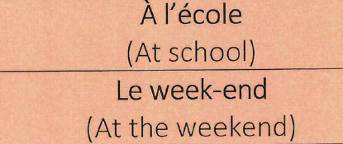
PE  - Team games  - dance | PE | PE  - Swimming
PSHE  Beginning and Belonging  Rules and responsibilities  My Emotions  Anti-Bullying | PSHE  Diversity and communities  Drug Education | PSHE  Personal Safety  Sex & Relationships  Education  Managing Change
Discovery RE  - Buddhism. What does it mean to be a Buddhist? Can we all be enlightened?  - How could we make our society equal?  - Christianity (Touch on it for Christmas) | - Christianity and Judaism. Is religion what you say or what you do?  - Why is it important to be good? | - Christians in other parts of the world.  - What is it like to be a Christian in Vellore?  - Learning from the Baja’I faith – unity
CUSP Science  - Properties and changes of materials (swapped from y5 curriculum)  - Animals, including humans | - Electricity  - Animals, including humans (water transport) | - Evolution and inheritance

Year B 2021 – 2022 curriculum content on a page
Autumn 2021 | Spring 2022 | Summer 2022
CUSP Reading  - Shackleton’s Journey.  - Secrets of a Sun King.  - If – Rudyard Kipling. | - A midsummer night’s dream.  - I am not a label.  - The Boy in the Tower.  - Daffodils – William Wordsworth. | - The Explorer.  - Five Children and It.
CUSP Writing  Introduce = green (Block A)  Revisit = orange (Block B)  - Balanced argument – builds on CUSP Disturbance of a natural habitat.  - Third person stories set in another culture.  - Poems that use word play – builds on CUSP Vocabulary in languages.  - Formal letters of application.  - Dialogue in narrative (first person myths and legends) – builds on CUSP Greeks and Maya. | - Biography – builds on CUSP Earth and space.  - Third person stories set in another culture – builds on CUSP location study.  - Poems which explore form.  - Playscripts (Shakespeare retelling).  - Formal letters of application – builds on CUSP design for a purpose.  - Poems that use word play. | - Balanced argument – builds on properties of materials.  - Poems which explore form – CUSP music lyrics.  - Playscripts.  - Dialogue in narrative (first person myths and legends) – builds on CUSP Ancient Greeks and Maya.  - Biography – builds on CUSP famous modern scientists.
Maths  Place value, Four Operations, Fractions (introduce decimals and percentages) | Geometry - properties of shapes (1)  Geometry - position and direction  Decimals and Percentages (recap fractions)  Practice tests  Measure - area and perimeter  Measure - volume and capacity  Graphs and tables | Measure - converting units  Decimals  Problem solving  Test practice
CUSP Art and Design  - Drawing and painting  - Printmaking | - Textiles and collage  - 3D | - NEW module  - School study or revisit previous module and sophisticate / elaborate
Computing (Kapow)  - Micro:bit  - Online safety Y5 | - Programming: music  - Stop motion animation | - Search engines  - Mars Rover 1 and / or 2
Design and Technology (Kapow)  - Food technology – what could be healthier  - Electrical systems - greeting cards | - Textiles – stuffed toys  - Structures: Bridges | - Food technology – eating seasonally  - Mechanical systems – Pop up books
CUSP Geography  - World countries – biomes and environmental regions | - 4 and 6 figure grid references | - Revisit world countries – biomes and environmental regions  - NEW OS maps and fieldwork
CUSP History  - Ancient Greeks | - Ancient Greeks  - Comparison study – Maya and Anglo-Saxons. | - Comparison study – Maya and Anglo-Saxons.
Music  - Music theory and The inter-related dimensions of music: Tempo, Dynamics, Duration, Structure, Pitch, Timbre, Texture  - Critical listening  - Compositional elements | Music  - Song composition and music manipulation. | Music  - Musical performance  - Music for Computer Games
MfL  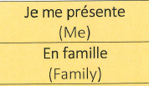 | MfL  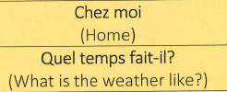 | MfL  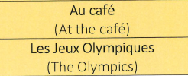
PE | PE | PE
PSHE  Beginning and Belonging  Family and Friends  Anti-Bullying | PSHE  Working Together  Financial Capability  Sex & Relationships  Education | PSHE  Managing Safety and Risk  Digital Lifestyles  Healthy Lifestyles
Discovery RE  - Hinduism. What can stories and images of deities tell us about Hindu beliefs?  - How and why do ‘religions’ help the poor? Fundraising/aid etc. | - Christianity. Who people say that I am? (Jesus explored through art).  - Are the Ten Commandments still relevant today? | - Beliefs and actions in the world. What key beliefs influence people’s faith and how do people live out their lives?  - How has religion influenced St Ives? Detectives – shop fronts, food, street names, art, statues etc.
CUSP Science  - Living things and their habitats (Swapped from y6)  - Light | - Earth in space  - Forces | - Living things and their habitats  - Forces continued

